

**DEPARTMENT OF INFORMATION TECHNOLOGY & COMMUNICATION**

**PROJECT REPORT**

**SMART RFID KAMSIS SYSTEM**

SUPERVISOR NAME:

ENCIK SABRI BIN SAEP

|  |  |  |
| --- | --- | --- |
| **STUDENT’S NAME** | **MATRIK NO** | **CLASS** |
| **MUHAMMAD HAFIZ BIN ZAKARIA** | **18DDT18F1034** | **DDT 5D** |
| **NURUL IZZAH `ATHIRAH BINTI ZAMURI** | **18DDT18F1075** | **DDT5D** |

* 1. INTRODUCTION

Tuanku Syed Sirajuddin Polytechnic is an IPTA located in Arau Perlis and is the 18th polytechnic in Malaysia. This polytechnic was formerly known as Perlis Polytechnic. At the polytechnic is a student residential college, every year there will be two semesters of study that take place in December and June.

The warden suggested a system to update the data of each occupant of the room and the inflow and outflow of occupants from the room. The system that is going to be done is based on web and mobile application. Meanwhile, the Mobile Application helps room occupants to open or close the key from a distance and helps the admin to send notifications to occupants if the door is not closed.

There are only 2 users in this system, namely residential college wardens and students

This system is created to overcome some problems that are:

1) Residential college warden: wants to reduce the cost of making locks every semester when there is a loss and negligence.

2) Students: face difficulties if keys are lost and room security is not tightly controlled.

The Polytechnic is committed to providing facilities for each occupant of the room as well as maintaining the safety of occupants in the event of intrusion or unwanted theft.

1

**1.2 PROBLEM STATEMENT**

Each semester the room key will be reduced among residents kamsis because lost and negligence. This is a problem for the warden kamsis as difficult for a new manufacturing process for the next semester because each semester will turn new residents.There are some significant negative consequences if a key is not returned or are lost due to the negligence of both parties. One effect is the warden had to create a new key so that new residents can enter the room.

**1.3 OBJECTIVE**

The main objective of Smart RFID KAMSIS DOOR LOCK.

1. Only room occupants can open and close the door.

2. reduce waste to create new locks.

3. Avoid aggression.

4. Students can access the mobile application to close and open doors from a distance.

5.Manage facilities information in Room

**2**

**1.4 Scope**

There are 5 types scope such as system scope, user scope, location scope, hardware scope and software. Below is the explanation for five scopes.

**1.4.1 System Scope**

System scope that we are developing by using Net Bean IDE, Android Studio, Kotlin, Arduino IDE, Xammp server Mysql. This system is help the warden of the kamsis politeknik to update room Student and access matrix cards as room keys.

There are two types of users in this system.Each of the user will have its own functionality. Warden kamsis be able to add or remove data occupants with using the system for each semester.Also, able to reset username and view all the updates that is updated by the admin.

Second is room occupants. Room Occupants can view the key is open or closed using application mobile system.When the door dont close, admin can send notification to application mobile occupants.

more over, Warden and room occupants can view every history log when the key is open dan close and manage facilities information in student Room

3

**1.4.2 User Scope**

i ) Admin

Warden kamsis is the admin of the system.The admin of the company is able to update,add and remove user of the system and view every history log when the door lock is open and closed.View all facilities information in student room.

ii ) Student

Student is able to open the door with matrik card.Also, can view the key is open or closed using application mobile system.Can update information about Item in room.

4

**1.4.3 Location scope**

This system will implement at Politeknik Tuanku Syed Sirajuddin, Pauh, Perlis.

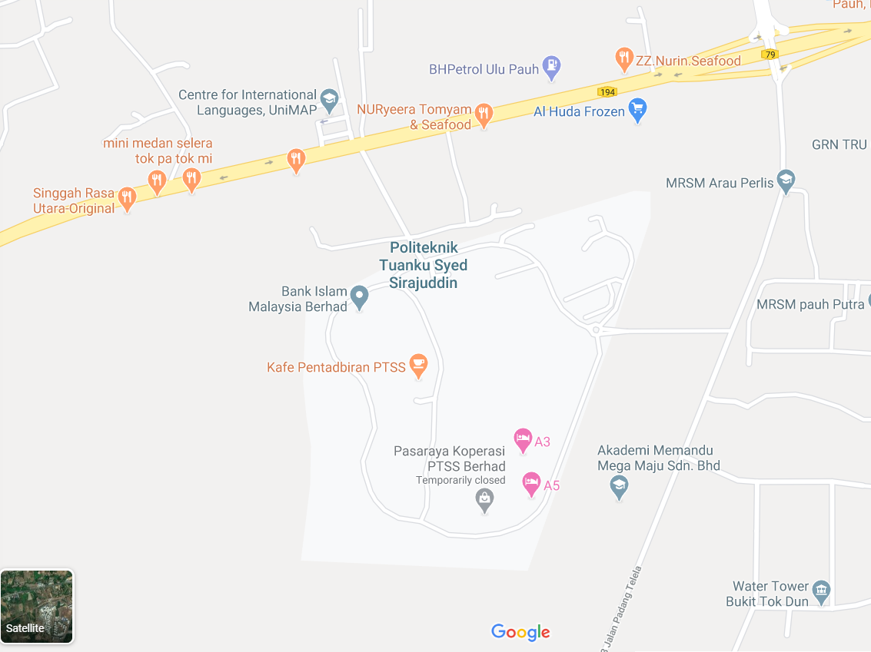

Figure 1.1 Location Politeknik Tuanku Syed Sirajuddin

5

**1.4.4 Software Scope**

To produce this system, there are some software used as in the table 1 below:

Table 1.1 : Software Scope

|  |  |
| --- | --- |
| **Software** | **Explaination** |
| Android Studio | To create App mobile for student |
| Arduino IDE | Program And set up Arduino Uno |
| NetBean IDE | To create web based interface |
| Xammp Server Mysql | Create Database |

6

**1.4.5 Hardware Scope**

Table 1.2 : Hardware Scope

|  |  |
| --- | --- |
| Hardware | Explaination |
| 1. Arduino uno | perform the same action multiple times in a program |
| 1. MRFC RFID522 RFID Scanner | To read RFID card |
| 1. 12V DC Solenoid Door Lock | electrical locking and unlocking |
| 1. Nodemcu EPS8266 | To control a digital output |
| 1. 2Channel Isolated 5V Relay(BT13-003) | allows a relatively low voltage to easily control higher power circuits |
| 1. Mini breadboard | make quick electrical connections between components |
| 1. Jumper cable 150mm | open or bypass part of an electronic circuit |

7

**1.5 Significant Project**

This Smart RFID kamsis saves time and reduces the cost of resetting the lock in the event of a loss while providing a better solution for the safety of each occupant of the room. Admin will update the occupant data and access the occupant matrix card as a room key. As for the mobile application, students can detect whether the room door is locked or not. If in one room there are 2 occupants, only the 2 occupants can access the rfid lock system .Admin can manage all Item information by mobile application and Warden can view every history log when the key is open dan close and manage item information in student Room.

* 1. **Literature Signifiant**

The main purpose of the literature review is to study the problem and assess the existing system, or any activity related to the projects to be developed. Collect information about the Smart RFID Kamsis Lock Door system, the system requirements and priority system should also be investigated. An interview with Warden Asrama Politeknik Tuanku Syed Sirajudin has done to collect information and to understand the Student,s requirements. Knowledge of kamsis key system information can also be gathered from observation and interview sessions.It will be easier for programmer to develop Smart RFID Kamsis Lock Door system.

Kamsis Politeknik Tuanku Syed Sirajudin have own record system ,so records on Website Ikamsis to book a room is the only method used for students to record all personal information and room information.

Moreover, comparisons between previous room lock systems can in Kamsis Politeknik Tuanku Syed Sirajudin also helps the developer to get some idea to determine the functions in new system

Furthermore, the study of literature is important in developing a project. It is done to collect various information related to the project in which this information will serve as guidelines and provide a clear picture of the project to be develop.

8

**1.6.1 System**

System design includes activities to conceive a system that answers an intended purpose, using principles and concepts, it includes assessments and decisions to select elements that compose the system, fit the architecture of the system, and comply traded-off system requirements. System design is the complete set of detailed models, properties or characteristics described into a form suitable for implementation .

The main System of RFID Kamsis system is use the database from Student,that can access by Warden(Admin).If Room has been book by Student ,the lock door will manually set up information about that student’s.

**1.6.2 Web Based**

System design includes admin interface on Web Based to access and update student information, admin can remove and add room occupants at any time. If the student break the rules on Kamsis , then the warden (admin) deserve to remove or warn the occupant of the room.Warden can access about item in every student room.

**1.6.3 Mobile Application(Kotlin)**

The system design for student includes interface on mobile application only that allow to update about personal information.That application have feature to notificate if the door lock was open,then can closed by this application from long distance.Futhermore, student must update about all item on room by scan qr code that has been provided.

**1.6.4 Database**

Smart RFID Kamsis is use Xammp server Mysql that can access by web based and mobile application java.

9

**1.6.5 System Comparison**

*RFID Door Lock System*

a) The arduino based RFIDdoor lock system is secure and responsive as compared to other systems. Withthe use of arduino, it becomes much easy to design. Program a code and uploadit to arduino just like a plug and play device. It is simple and cost efficientproject and can be used as a basic access control mechanism. Their main advantageis contactless communication and RFID tags can work in any environmentalconditions. This is the reason RFID systems are more efficient

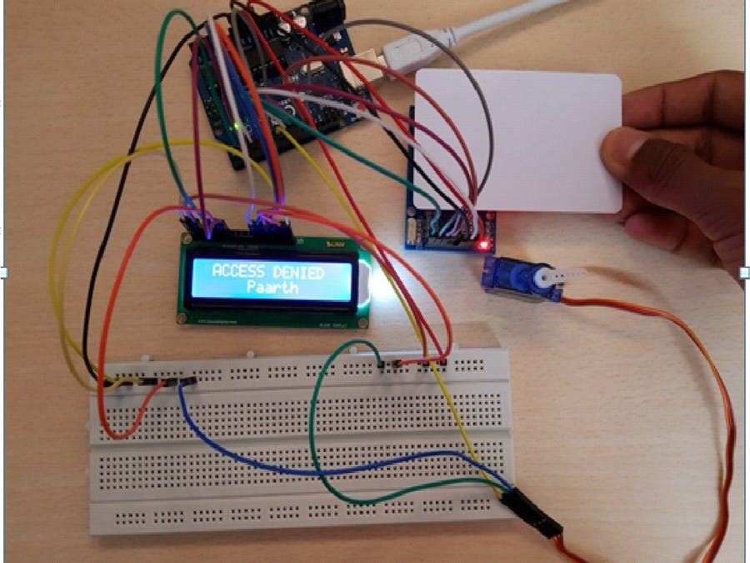

1. Advantage:

* User can access use Rfid cad only
* Can acces multiple database

1. Disadvantage

* Cannot connect to mobile phone
* User can connect by rfid can only

10

*RFID door lock Servo motor*

b) Now as the tag is powered it can extract the transmitted message from the reader, and for sending message back to the reader, it uses a technique called load manipulation. Switching on and off a load at the antenna of the tag will affect the power consumption of the reader’s antenna which can be measured as voltage drop. This changes in the voltage will be captured as ones and zeros and that’s the way the data is transferred from the tag to the reader.

There’s also another way of data transfer between the reader and the tag, called backscattered coupling. In this case, the tag uses part of the received power for generating another electromagnetic field which will be picked up by the reader’s antenna.

1. Advantage

* Character display

1. Disadvantage

* Servo motor is not strong enough to lock the door
* The door can’t be access if rfid card missing.

11

*Personal RFID lock*

c) An RFID based Door Lock is based on some simple concepts. We store a set of RFID card data in our system, say 3 or 10 RFID card data. When the person with the right RFID card (compatible to data preloaded in our program/system) come and swipes his RFID tag, access will be granted. When the person with the wrong RFID card (whose data is not loaded in our system) swipes his RFID tag, access will be denied. I hope you understand the system concept of RFID based Door Lock

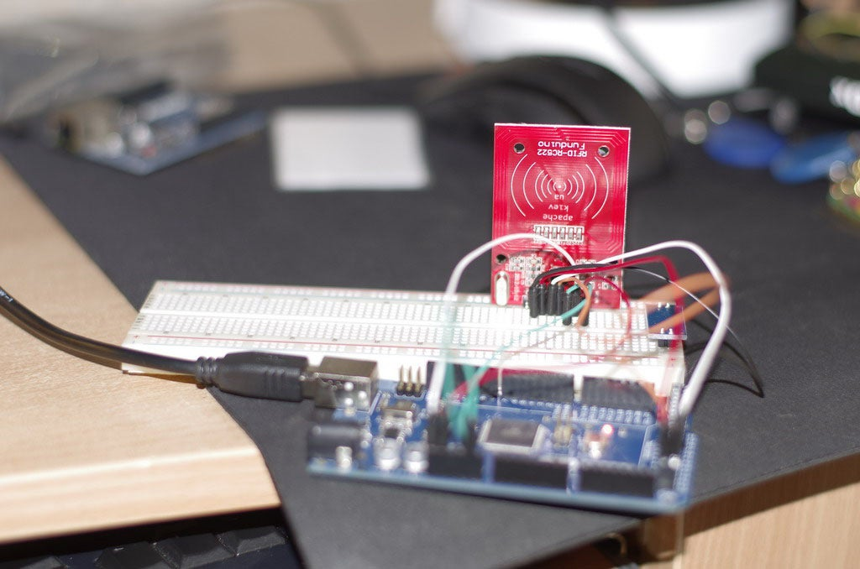

1. Advantage

* User easy to access by RFID Card Only
* No more key to open the door

1. Disadvantage

* Don’t have multiple user database
* Can access by rfid card only

12

|  |  |  |  |  |
| --- | --- | --- | --- | --- |
| System Name  Function | RFID Door Lock | RFID door lock Servo motor | Personal RFID lock | Smart RFID Kamsis |
| Rfid Scanner | **✓** | ✓ | ✓ | ✓ |
| Multiple Database | ✓ | ✓ | ✕ | ✓ |
| Database | Mysql | Mysql | Mysql | Mysql |
| Mobile Application | ✕ | ✕ | ✕ | ✓ |
| Webbased interface | ✕ | ✕ | ✕ | ✓ |
| Notication system | ✕ | ✕ | ✕ | ✓ |
| Character Display | ✓ | ✓ | ✕ | ✕ |
| Log In System | ✕ | ✕ | ✕ | ✓ |
| User information on RFID card | ✕ | ✕ | ✕ | ✓ |

13

* 1. **Methodology**
     1. **Introduction**

Project management teams clung to the traditional approach of strict planning, process, and documentation. Agile management turns this approach on its head, and it’s no wonder that this methodology has become more popular over time. According to a 2017 study from PwC, agile projects are 28% more successful than traditional projects.And project managers have taken notice particularly among teams in industries like software development where technology, objectives, and targets are in constant flux.

**1.7.2 Rapid Application Development (RAD)**

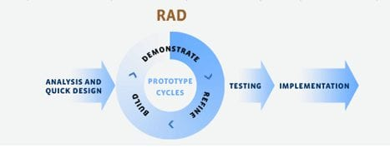The Rapid Application Development (or RAD) model is based on prototyping and iterative model with no (or less) specific planning. In general, RAD approach to software development means putting lesser emphasis on planning tasks and more emphasis on development and coming up with a prototype. In disparity to the waterfall model, which emphasizes meticulous specification and planning, the RAD approach means building on continuously evolving requirements, as more and more learnings are drawn as the development progresses.

Figure 2.1: Rapid Application Development

14

* + 1. **Rapid Application Development Phase**

Phase 1 – Analysis

In this analysis phase,we choose our Polythechnic for our project at Pauh,Perlis. Then, we make an appointment on 17 august 2020. Then, interview the person in charge of the Kamsis Polythecnic. Ask question about lock system in kamsis .Lastly, list the current problem and find requirement of system.

Phase 2 – Design

In this design phase, create use case diagram to show the functionality of system, create Entity Relationship Diagram (ERD) to represent the data in database, create Data Flow Diagram to show the data flow involved in the system, create context diagram, create storyboard of interface and create interface of system.

Phase 3 – Development

In this development phase, we create web based interface for admin page manualy,create mobile application interface for student’s, create system by using Arduino, create database by using Xammp Server Mysql and create connection database

Phase 4 – Testing

In this phase, will test database and developed a program to access the system built. The system developed will be accessed arduino it can operate perfectly or not. The system will be tested to determine if there is any error in system developed.

15

* 1. **Gantt Chart**

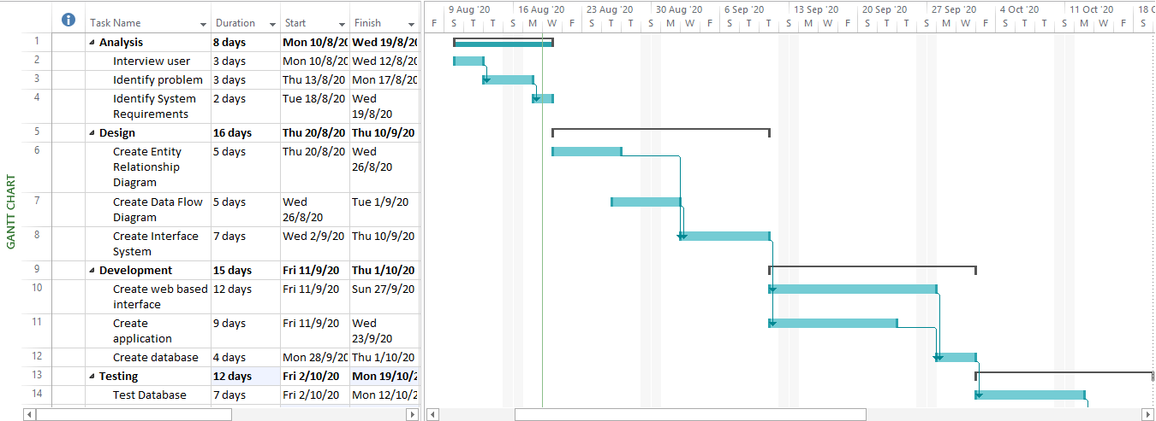

16

**1.9 Cost Planning**

|  |  |  |  |  |
| --- | --- | --- | --- | --- |
| No. | Item | Quantity | Cost(RM) | Total Cost(RM) |
| 1 | Hardware   1. Arduino uno 2. MRFC RFID522 RFID Scanner 3. 12V DC Solenoid Door Lock 4. Nodemcu EPS8266 5. 2Channel Isolated 5V Relay(BT13-003) 6. Mini breadboard 7. Jumper 8. Laptop 9. Android Mobile Phone | 1  1  1  1  1  1  1  1  1 |  |  |
| 2 | Sofware   1. Arduino IDE 2. NetBean IDE 3. Xammp server Mysql 4. Android Studio(Kotlin) | 1  1  1  1 |  |  |
| 3 | Total |  |  |  |

**17**

**2.1 Conclusion**

The implementation of door access system is considered to be a need for a building especially companies to have a security system in order to keep the people inside and assets to be safe from unwanted cases such as burglaries,

Also, a smart lock system is presented which is a novel access control system using IOT which includes the online monitoring. The smart lock system provide a convenient way to automate the access control feature thereby enhancing security . It is a low cost, flexible, and a very easy to install system with no overhead like planning, cabling, and construction works.

18

**2.2 REFERENCE**

1. SHUHADA NATASHA BINT MOHD ZAINOR, September 2012,“DOOR ACCESS SYSTEM – ARDUINO BASED”.
2. Shrinidhi Gindi1, Naiyer Shaikh, Kashif Beig, Abdeali Sabuwala, July 2020,“Smart Lock System Using RFID”, International Research Journal of Engineering and Technology (IRJET).
3. Kuei-Mei Cheng,december 2012,A Study of the RFID Door Security System in the Feng Chia

University,

1. Tarun Agarwal, (2015), "RFID based Automatic Door Lock System with Arduino", Retrieved 19 October 2017, from <https://www.elprocus.com/automatic-door-lock-system-using-rfid-and-arduino/.>
2. Ramalatha, M., Ramkumar, A. K., Selvaraj, S. and Suriyakanth, S, (2014), “RFID Based Personal Medical Data card for Toll Automation”. Elysium Journal Engineering Research and Management. Volume1, ISSN: 2347-4408, pp 51-52.

6. Umar Farooq, Mahmood ul Hasan, Muhammad Amar, Athar Hanif, and Muhammad Usman Asad, (2014), "RFID Based Security and Access Control System" IACSIT International Journal of Engineering and Technology, Vol. 6, No. 4, August 2014.

7.Peter Adole1, Joseph M. Môm and Gabriel A. Igwue, (2016), "RFID Based Security Access Control System with GSM Technology", American Journal of Engineering Research (AJER) e-ISSN: 2320- 0847 p-ISSN: 2320-0936 Volume-5, Issue-7, pp-236-242.

8.Dejan Nedelkovski, (2017), "How RFID Works and How To Make an Arduino based RFID Door Lock - HowToMechatronics”.

19